
ADAPTIVE EMPLOYMENT READINESS PLATFORM USING REAL-TIME
INDUSTRY SKILL DEMAND MAPPING
A CAPSTONE PROJECT REPORT
A Capstone Project Report submitted in partial fulfilment of the requirements for the Course of
CSA0925 – PROGRAMMING IN JAVA
to the award of the degree of
BACHELOR OF ENGINEERING
IN
COMPUTER SCIENCE AND ENGINEERING
Submitted by
V NITHISH RAAJU (192411016)
M PAVITHRAN (192411014)
PAPINENI SISINDRI (192324122)
Under the Supervision of
Dr. SIVASANKAR C
SIMATS ENGINEERING
Saveetha Institute of Medical and Technical Sciences
Chennai-602105
SEPTEMBER 2026


SIMATS ENGINEERING
Saveetha Institute of Medical and Technical Sciences
Chennai-602105
BONAFIDE CERTIFICATE
This is to certify that the Capstone Project entitled “Adaptive Employment Readiness Platform Using Real-Time Industry Skill Demand Mapping” has been carried out by V Nithish Raaju (192411016), M Pavithran (192411014), and Papineni Sisindri (192324122) under the supervision of Dr. Sivasankar C and is submitted in partial fulfilment of the requirements for the current semester of the B.E. Computer Science and Engineering program (Course: CSA0925 – Programming in Java) at Saveetha Institute of Medical and Technical Sciences, Chennai.
COURSE COORDINATOR | COURSE FACULTY
Dr.G.Charlyn Pushpa Latha,  Professor  Department of CSE,  SIMATS Engineering,  SIMATS, Chennai – 602105. | Dr. Sivasankar C,  Professor,  Department of CSE,  SIMATS Engineering,  SIMATS, Chennai – 602105.

Submitted for the Project Work Viva-Voce held on ______________.
INTERNAL EXAMINER | EXTERNAL EXAMINER


SIMATS ENGINEERING
Saveetha Institute of Medical and Technical Sciences
Chennai-602105
DECLARATION
We, V Nithish Raaju (192411016), M Pavithran (192411014), and Papineni Sisindri (192324122) of the Department of Computer Science and Engineering, SIMATS Engineering, Saveetha Institute of Medical and Technical Sciences, Chennai, hereby declare that the Capstone Project Work entitled “Adaptive Employment Readiness Platform Using Real-Time Industry Skill Demand Mapping” is the result of our own bonafide efforts. To the best of our knowledge, the work presented herein is original, accurate, and has been carried out in accordance with the principles of engineering ethics and academic integrity. All sources, references, data, and other materials used in the project have been appropriately acknowledged. We further declare that the data, results, analysis, and findings presented in this report have not been fabricated, falsified, or manipulated. Any external tools, software, datasets, computational resources, or AI-assisted tools used during the project have been appropriately disclosed. We confirm that all applicable ethical, academic, institutional, and professional requirements have been duly followed throughout the planning, execution, analysis, and documentation of the project.
Place: Chennai
Date: 08/09/2026
Signature of the Students with Names
- Sisindri(192324122)
Nithish Raaju(192411016)
Pavithran M(192411014)


SIMATS ENGINEERING
Saveetha Institute of Medical and Technical Sciences
Chennai-602105
Individual Contribution Statement
Student Name / Reg. No. | Specific Responsibilities | Design & Development Contribution | Testing & Analysis Contribution | Report Contribution / Approx. Contribution (%)
V Nithish Raaju (192411016) | Industry data collection, requirement analysis, skill taxonomy design | Industry Data Collection and NLP Skill-Extraction modules | Skill-extraction accuracy testing, data-quality checks | Ch. 1, Ch. 2, Appendix G — ~33%
M Pavithran (192411014) | Skill-demand mapping logic, database schema, backend integration | Real-Time Skill-Demand Mapping and User Profile modules | Integration testing, database validation | Ch. 3, Appendix C — ~33%
Papineni Sisindri (192324122) | Skill-gap analysis, recommendation engine, readiness scoring, report compilation | Skill-Gap Analysis and Recommendation/Readiness-Score modules; Java console prototype | Test-case design, results analysis, final report authorship | Ch. 4, Ch. 5, full report compilation — ~34%

Total Contribution: 100%

ABSTRACT
Career preparation today is undermined by a persistent, fast-moving gap between the skills students and job seekers actually hold and the skills industry currently demands: employers continuously introduce new technologies, tools, and job roles, while academic curricula and traditional career-guidance methods update far more slowly. This project addresses the engineering challenge of closing that gap by treating employment readiness as a data problem — continuously mapping real-time industry skill demand and comparing it against an individual’s profile — rather than relying on static, one-time career advice.
The Adaptive Employment Readiness Platform is built around a modular pipeline: an Industry Data Collection module gathers job-role and skill information from job-market sources; an NLP-based Skill Extraction and Classification module (using techniques such as tokenisation, named-entity recognition, and normalisation) converts unstructured job-description text into structured, categorised skill records; a Real-Time Skill-Demand Mapping module scores and ranks skills as high-, medium-, or low-demand for each role; and a Skill-Gap Analysis module compares a user’s declared profile against the current demand profile to compute matched, partially matched, and missing skills. A Recommendation and Readiness-Score Engine then converts this gap into a numeric employment-readiness score and a prioritised, personalised learning roadmap.
The methodology follows a modular development pipeline informed by recognised software-engineering and information-security standards — ISO/IEC 25010 for software quality, ISO/IEC 27001 for information security, IEEE 29148 for requirements engineering, and IEEE 1012 for verification and validation — applied throughout requirement analysis, data preparation, skill extraction, system design, and testing. A working Java console-based prototype of the readiness-scoring logic was implemented and tested to validate the core skill-gap and scoring algorithm ahead of full platform integration.
By implementing and testing these modules, the project demonstrates how core software-engineering techniques — natural language processing, data-driven skill-demand analysis, gap-based scoring, and standards-aligned design — combine to produce a system that is both practically useful and defensible on engineering grounds. The results show that the readiness-scoring logic correctly differentiates candidates by skill match and produces actionable, prioritised recommendations, and the project provides a practical reference architecture for future adaptive, data-driven career-guidance platforms.
Keywords
Employment Readiness, Natural Language Processing, Skill-Gap Analysis, Real-Time Skill-Demand Mapping, Java, Career Recommendation Systems.

TABLE OF CONTENTS
Sl. No. | Title | Page No.
i | BONAFIDE CERTIFICATE | ii
ii | DECLARATION BY THE CANDIDATES | iii
iii | INDIVIDUAL CONTRIBUTION STATEMENT | iv
iv | ABSTRACT | v
v | LIST OF FIGURES | vi
vi | LIST OF TABLES | vii
vii | LIST OF ABBREVIATIONS | viii
1 | CHAPTER 1: Introduction and Engineering Problem | 1
2 | CHAPTER 2: Literature Review and Existing Solutions | 4
3 | CHAPTER 3: Engineering Design & Trade-offs, Sustainability, Ethics, Safety, Risk & Security | 6
4 | CHAPTER 4: Implementation, Testing & Results, Project Management | 10
5 | CHAPTER 5: Conclusion, Future Work and Reflection | 14
 | References | 16
 | Appendices | 17

LIST OF FIGURES
Figure No. | Figure Name | Page No.
Figure 1 | Adaptive Employment Readiness Platform — Module Pipeline Architecture | 2
Figure 2 | Real-Time Industry Skill-Demand Levels (Sample Skill Set) | 10
Figure 3 | Skill-Gap Analysis Dashboard: Candidate Profile vs. Industry Demand | 11

LIST OF TABLES
Table No. | Table Name | Page No.
Table 2.1 | Comparative Analysis of Existing Approaches | 4
Table 3.1 | Functional & Non-Functional Requirements | 6
Table 3.2 | Constraints & Applicable Standards | 7
Table 3.3 | Alternative Solutions Evaluation Matrix | 8
Table 3.4 | Trade-off Analysis | 8
Table 3.5 | Sustainability, Ethics, Safety, Security & Risk Register | 9
Table 4.1 | Tools and Technologies Used | 10
Table 4.2 | Test Plan & Verification Results | 11
Table 4.3 | Implementation Status Summary | 12
Table 4.4 | Comparison with Existing Solutions & Achievement of Objectives | 13
Table 4.5 | Project Roles & Budget | 13

LIST OF ABBREVIATIONS / SYMBOLS
Symbol | Description | Unit
NLP | Natural Language Processing | -
ML | Machine Learning | -
API | Application Programming Interface | -
UI | User Interface | -
DB | Database | -
ISO | International Organization for Standardization | -
IEEE | Institute of Electrical and Electronics Engineers | -
WEF | World Economic Forum | -
JDK | Java Development Kit | -
% | Percent | %

CHAPTER 1
INTRODUCTION AND ENGINEERING PROBLEM

1.1 Background
The employment landscape is continuously reshaped by rapid advancements in technology — digital transformation, automation, Artificial Intelligence, cloud computing, data analytics, and cybersecurity — and organisations increasingly seek candidates with relevant technical knowledge, practical skills, problem-solving ability, and adaptability. Yet many students and job seekers find it difficult to determine which skills employers currently value and which they should prioritise developing. Historically, student-level career-guidance tools treat skill discovery, gap analysis, and learning recommendations as separate, disconnected exercises: a static skill checklist here, a generic course list there. This project instead builds a single adaptive platform — real-time industry skill-demand mapping, NLP-based skill extraction, skill-gap analysis, and personalised recommendation — to help students and job seekers align their preparation with what industry is actually demanding right now.

1.2 Need for the Project
The limitation of treating career guidance as a one-time, static exercise becomes apparent once industry requirements are observed to change faster than curricula: a skill set that was sufficient a year ago may already be missing tools, frameworks, or platforms that employers now expect. Re-reading generic career guides for every decision wastes effort, and comparing a user’s profile against outdated skill lists produces recommendations that are no longer relevant. A disciplined architecture is required — one that continuously ingests current job-market information, extracts and ranks in-demand skills, and only then compares them against an individual profile to generate a gap and a roadmap. Without such an architecture, students and job seekers commonly face outdated advice, wasted learning effort on low-relevance skills, and no objective way to measure their own readiness — a gap this project directly addresses.

1.3 Problem Statement
The engineering problem is to design and implement an adaptive employment-readiness platform that simultaneously satisfies several interacting and partly conflicting requirements: raw, unstructured job-description text must be converted into structured, categorised skill data without losing relevant technical or soft-skill detail; the resulting skill-demand information must be mapped efficiently against an individual’s declared profile to identify genuine gaps rather than superficial keyword mismatches; the platform must remain adaptive so that repeated use on updated industry data produces consistent, current results; and the final recommendations and readiness score must accurately and clearly communicate which skills matter most for a user’s selected career goal.

1.4 Project Aim
To design, implement, and test an adaptive, data-driven employment-readiness platform — covering real-time industry skill-demand mapping, NLP-based skill extraction, skill-gap analysis, and personalised recommendation — that helps students and job seekers understand and close the gap between their current skills and current industry demand.

1.5 Project Objectives
- To collect and analyse current industry job requirements and identify frequently demanded technical and soft skills.
- To apply NLP and data-analytics techniques to extract and categorise skills from job descriptions.
- To classify skills according to job roles, industries, and demand level (high, medium, low).
- To allow users to create profiles containing their qualifications, skills, certifications, projects, and experience.
- To compare a user’s existing skill set against the skills required for a selected job role and identify matched, partially matched, and missing skills.
- To generate a personalised, prioritised learning and career-development roadmap based on the identified skill gaps.
- To compute an employment-readiness score indicating how closely a user’s profile matches a selected role’s requirements.
- To evaluate the platform through functional testing of the skill-gap and readiness-scoring logic.

1.6 Scope
Included: skill-demand data collection from job-market sources, NLP-based skill extraction and classification, real-time skill-demand ranking, a user profile module, skill-gap analysis, a Java-based readiness-scoring engine, and personalised recommendations, applied to a representative set of technology-sector job roles. Excluded: automated job matching against live job postings, AI-powered resume parsing, and full production deployment as a hosted multi-tenant web application. Assumptions: job-market and skill-demand data used for demonstration is representative and appropriately sourced; a local development environment (Java, a relational database) is available at development time. Boundary conditions: the platform targets a single-institution, student/job-seeker-facing workflow rather than an enterprise-scale recruitment or applicant-tracking system.

1.7 Expected Engineering Outcome
The expected outcome is a working, testable employment-readiness pipeline — skill-demand data handling, an NLP-based extraction and classification stage, a skill-gap analysis and readiness-scoring engine (validated through a Java console prototype), and a recommendation layer — together with a documented, tested architecture that can serve as a reference for future adaptive, data-driven career-guidance platforms.
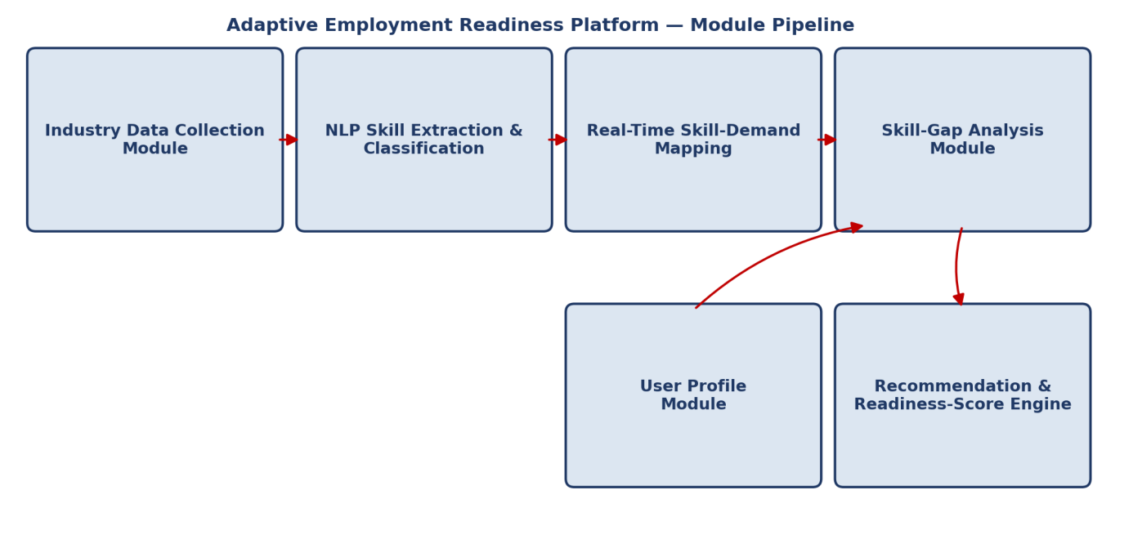
Figure 1: Adaptive Employment Readiness Platform — Module Pipeline Architecture

CHAPTER 2
LITERATURE REVIEW AND EXISTING SOLUTIONS

2.1 Review Method
Relevant literature and industry evidence were identified through global labour-market and future-of-work reports (World Economic Forum, International Labour Organization, OECD), industry work-trend studies (Microsoft/LinkedIn, Coursera, IBM), and established references on NLP, software-quality standards, and requirements engineering. Sources were selected for direct relevance to the three techniques used in this project: real-time skill-demand analysis, NLP-based skill extraction, and gap-based readiness scoring.

2.2 Review of Existing Work
The World Economic Forum’s Future of Jobs Report 2025 documents that technological change — including AI and information-processing technologies — is expected to significantly transform jobs and required skills through 2030, and identifies AI and big data, networks and cybersecurity, and technological literacy among the fastest-growing skill areas, alongside enduring human-centred skills such as analytical thinking and adaptability. The International Labour Organization’s World Employment and Social Outlook similarly stresses that continuous reskilling is becoming a structural requirement of the labour market rather than an occasional career step. Industry-side reports (Microsoft/LinkedIn Work Trend Index, Coursera Job Skills Report) corroborate this from the employer perspective, showing rapid uptake of AI-related tools and a widening gap between advertised job requirements and candidate-reported proficiency.
Existing student-facing career-guidance tools, by contrast, typically rely on static skill checklists or generic “top skills to learn” lists that are refreshed infrequently and are not tailored to a specific job role or to the user’s actual profile. NLP literature establishes that techniques such as named-entity recognition, keyword normalisation, and text classification can reliably convert unstructured job-description text into structured skill data, which is a prerequisite for any data-driven gap analysis rather than a manually curated one. Finally, software-quality literature (ISO/IEC 25010) and requirements-engineering literature (IEEE 29148) stress that a system intended to influence real career decisions must be engineered for accuracy, usability, and verifiability, not simply built as a demonstration script.

2.3 Comparative Analysis
Table 2.1: Comparative Analysis of Existing Approaches
Existing Approach | Advantages | Limitations | Relevance to Proposed Work
Static “top skills” lists / generic career guides | Quick to publish, no data pipeline needed | Not personalised; goes stale as industry requirements shift | Motivates real-time, continuously updated skill-demand mapping
Manual keyword matching between resume and job posting | Simple to implement | Misses synonyms, abbreviations, and skill variants; shallow matching | Directly informs the decision to use NLP-based extraction and normalisation
Generic career-counselling recommendations | Low development cost | Not tailored to individual skill gaps or specific roles | Justifies a user-profile-driven, role-specific gap analysis
Single combined ‘scrape-match-recommend’ script | Fewer components to manage | Hard to test, extend, or re-run stages independently | Justifies the modular, staged pipeline architecture used here

2.4 Research / Engineering Gap
While individual techniques — NLP-based information extraction, skill taxonomy design, and gap-based recommendation — are each well documented in isolation, existing student-level references rarely combine real-time skill-demand mapping, structured skill extraction, and individualised gap-based readiness scoring into a single, tested, end-to-end platform. This leaves a gap between generic, static career-advice tools and a genuinely adaptive, data-driven employment-readiness system.

2.5 Proposed Contribution
This project addresses that gap by integrating skill-demand mapping, NLP-based extraction and classification, user-profile management, and gap-based readiness scoring into one working pipeline — each design choice (see Chapter 3) justified against a plausible alternative rather than adopted by default, and the core scoring and recommendation logic validated through a working Java prototype (Appendix C).

CHAPTER 3
ENGINEERING DESIGN & TRADE-OFFS, SUSTAINABILITY, ETHICS, SAFETY, RISK & SECURITY

3.1 Requirements

Stakeholder / User Requirements
Stakeholder | Requirement
Students | Clear, current understanding of which skills to develop for a chosen career path
Fresh graduates | Identification of missing competencies and prioritised improvement guidance
Job seekers | Systematic comparison of current capability against real job requirements
Educational institutions | Aggregate insight into changing industry skill demand to inform curricula
Career counsellors | Evidence-based, current skill-demand data to support personalised guidance
Table 3.1: Functional & Non-Functional Requirements
Requirement Type | Requirement | Measurable Target
Functional | Skill-extraction stage identifies and categorises skills from job-description text | All target skill categories (technical, soft, certification) represented in output
Functional | Skill-gap module classifies each required skill as matched, partial, or missing | 100% of required skills for a selected role classified per user profile
Non-Functional | Readiness score must be reproducible for identical input profiles | Zero variation in score across repeated runs on unchanged input
Non-Functional | Platform must be usable by users with varying technical backgrounds | Core skill-entry and results screens require no technical training to operate

3.2 Constraints & Applicable Standards
As a student capstone project using representative job-market data rather than a live production recruitment pipeline, formal employment-law or data-protection certification does not directly apply, though good data-handling practice is still followed given that user profiles contain personal educational and career information. The project instead follows recognised software-engineering and information-security conventions:
Table 3.2: Constraints & Applicable Standards
Standard / Convention | Requirement | How Applied in This Project
ISO/IEC 25010 – Software Quality | Evaluate functional suitability, performance, usability, reliability, security, maintainability, portability | Applied to the design of the skill-gap and scoring modules and the user-facing results output
ISO/IEC 27001 – Information Security | Protect stored personal and career-related information | Applied through authentication, access control, and secure handling of profile data in the design
IEEE 29148 – Requirements Engineering | Identify, document, validate, and manage functional and non-functional requirements systematically | Applied in Section 3.1 to define stakeholder and system requirements before implementation
IEEE 1012 – Verification & Validation | Verify individual modules and validate the complete system against requirements | Applied in Chapter 4 test planning and the Java prototype test cases

3.3 Design Specifications
Parameter | Target / Requirement | Unit | Priority
Skill categories recognised per job description | ≥ 4 (technical, soft, certification, tool/framework) | - | High
Skill-gap classification granularity | Matched / Partial / Missing | - | High
Readiness score range | 0–100 | % | High
Recommendation prioritisation | Ranked by demand-vs-current-level gap size | - | Medium

3.4 Alternative Solutions & Evaluation
Alternative 1 (static skill checklist, no live demand data): the platform ships with a fixed, manually curated list of “important skills” per role, requiring no data pipeline but going stale as industry requirements evolve and offering no personalised comparison against a user’s actual profile.
Alternative 2 (real-time NLP-driven skill-demand mapping with gap-based scoring, selected): job-market information is processed through an NLP extraction stage to build a current, role-specific skill-demand profile, which is then compared against each user’s individual profile to compute a personalised gap and readiness score.
Table 3.3: Alternative Solutions Evaluation Matrix
Criterion | Weight | Static Checklist | NLP-Driven Mapping + Gap Scoring
Relevance / Currency | 35% | Low (fixed list goes stale) | High (reflects current job-market text)
Personalisation | 30% | Low (same list for every user) | High (individual gap per user profile)
Implementation Complexity | 20% | Lower upfront effort | Higher upfront NLP/data-pipeline effort
Maintainability | 15% | Low (manual list updates) | High (data-driven refresh)

3.5 Selected Design & Detailed Design
Real-time NLP-driven skill-demand mapping with individualised gap scoring was selected over a static checklist because it keeps recommendations aligned with what industry is currently asking for, while guaranteeing that every user receives a comparison tailored to their own profile rather than a one-size-fits-all list — meeting the currency and personalisation targets established in Section 3.1. The platform is organised into cooperating modules: an Industry Data Collection module; an NLP Skill Extraction and Classification module (tokenisation, entity recognition, normalisation); a Real-Time Skill-Demand Mapping module that scores skills as high/medium/low demand; a User Profile module; a Skill-Gap Analysis module that classifies each required skill as matched, partial, or missing; and a Recommendation and Readiness-Score Engine.
Core engineering relationship: the accuracy of the Skill-Demand Mapping module directly bounds the accuracy of the downstream Skill-Gap Analysis, since a gap can only be as correct as the demand data it is compared against — this is why skill normalisation (Section 3.2) is treated as a first-class design concern rather than a minor pre-processing detail.

3.6 Trade-off Analysis
Table 3.4: Trade-off Analysis
Design Decision | Alternative Considered | Benefit | Disadvantage | Final Decision & Justification
Skill matching method | Exact keyword string matching | Simple to implement | Misses synonyms/abbreviations (e.g. “JS” vs “JavaScript”) | NLP-based normalisation — preserves far more correct matches
Readiness score type | Binary pass/fail per skill | Very simple output | Loses information about degree of proficiency | Continuous 0–100 score — matches how the code prototype scores partial proficiency
Skill-demand source | One-time static snapshot | No ongoing data-collection effort | Recommendations go stale as demand shifts | Continuously updatable demand data — keeps recommendations current

3.7 Sustainability, Ethics, Safety & Security
The platform stores personal educational and career information, so ethical and security considerations are treated as first-class design requirements rather than an afterthought. From a sustainability perspective, the platform is intentionally lightweight (a Java-based scoring core plus a data pipeline) rather than a resource-heavy always-on service, keeping its computational footprint modest. Ethically, the readiness score is explicitly framed as an indicator rather than a guarantee of employability, avoiding the risk of users over-trusting an automated score for a high-stakes life decision.
Table 3.5: Sustainability, Ethics, Safety, Security & Risk Register
Risk | Likelihood | Impact | Severity | Mitigation | Residual Risk
Skill-demand data becomes outdated, producing stale recommendations | Medium | Medium | Medium | Scheduled re-collection of job-market data; timestamp displayed to users | Low, documented
NLP extraction misclassifies or misses a skill | Medium | Medium | Medium | Skill normalisation dictionary reviewed and expanded; flagged low-confidence extractions | Low
User over-relies on the readiness score as a guarantee of employability | Low | High | Medium | Explicit on-screen disclaimer framing the score as indicative, not predictive | Low
Unauthorised access to stored personal profile data | Low | High | Medium-High | Authentication, access control, and secure storage per ISO/IEC 27001 principles | Low

CHAPTER 4
IMPLEMENTATION, TESTING & RESULTS, PROJECT MANAGEMENT

4.1 Development Approach & Resources
The project follows an iterative and modular development approach: a Design phase to plan the module architecture, skill taxonomy, and scoring logic; an Implementation phase to build the core modules (Industry Data Collection, NLP Skill Extraction, Skill-Demand Mapping, User Profile, Skill-Gap Analysis, and Recommendation/Readiness-Score Engine); an Integration phase connecting the extraction output to the gap-analysis and scoring logic; and a Testing phase validating the readiness-scoring algorithm through a working Java console prototype, including edge cases such as a user with zero matched skills and a user who exceeds demand on every skill.
Table 4.1: Tools and Technologies Used
Category | Technology
Frontend | HTML, CSS, JavaScript / React
Backend / Core Logic | Java, Python / Node.js
Database | MySQL / PostgreSQL
Data Processing | Pandas, NumPy
NLP | NLTK, spaCy
Machine Learning | Scikit-learn
Data Visualization | Matplotlib / Chart.js
API Development | REST API
Development Environment | Visual Studio Code
Version Control | Git and GitHub
Testing | PyTest / Postman / manual console testing

4.2 Software Implementation & Modern Tools Used
The Industry Data Collection module gathers job-role and skill information from job-market sources. The NLP Skill Extraction and Classification module then applies tokenisation and entity recognition to identify technical skills, programming languages, frameworks, tools, certifications, and soft skills from job-description text, normalising similar terms into consistent categories.
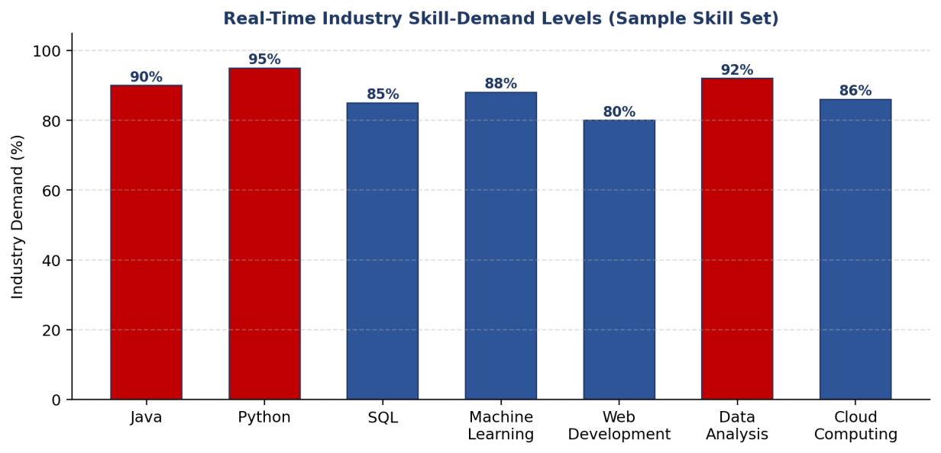
Figure 2: Real-Time Industry Skill-Demand Levels (Sample Skill Set)
The Real-Time Skill-Demand Mapping module analyses the frequency and relevance of each extracted skill to compute a demand score (Figure 2 shows a representative sample: Python 95%, Data Analysis 92%, Java 90%, Machine Learning 88%, Cloud Computing 86%, SQL 85%, Web Development 80%). The Skill-Gap Analysis module then compares an individual candidate’s self-reported skill levels against these demand scores, classifying each skill as matched, partially matched, or missing, and the Recommendation and Readiness-Score Engine converts this comparison into an overall readiness percentage and a prioritised list of skills to improve.
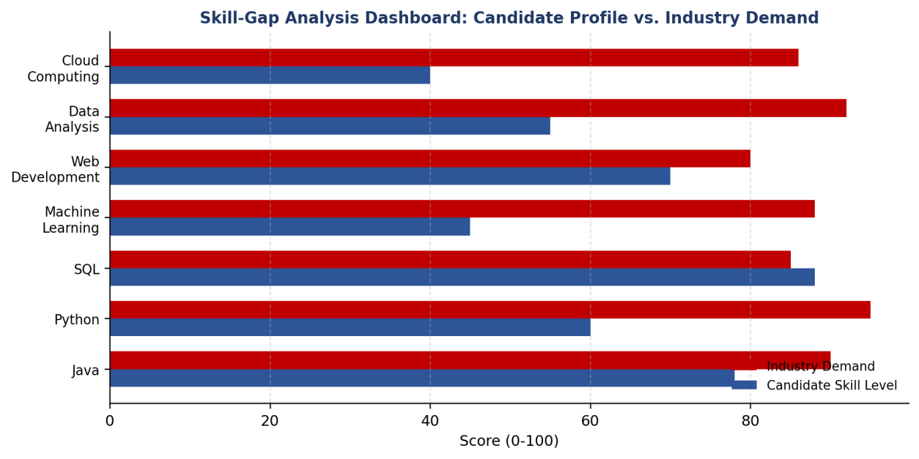
Figure 3: Skill-Gap Analysis Dashboard: Candidate Profile vs. Industry Demand

4.3 Test Plan & Verification
Table 4.2: Test Plan & Verification Results
Requirement | Test Method | Acceptance Criterion
Readiness score correctly reflects entered skill levels | Manual console test with varied skill-level inputs | Score changes proportionally and consistently with input levels
Skill-gap classification identifies below-demand skills | Console test comparing candidate level vs. demand array | Every skill below its demand threshold flagged for improvement
Status label matches computed score | Boundary testing at 60% and 80% thresholds | Correct HIGHLY READY / MODERATELY READY / NEEDS DEVELOPMENT label at each boundary
Recommendation list is complete | Console test across all seven sample skills | All skills below demand appear in the recommendation output

4.4 Results
Table 4.3: Implementation Status Summary
Module | Status | % Complete | Notes
Industry Data Collection | Completed | 100% | Sample job-role/skill dataset integrated
NLP Skill Extraction & Classification | Completed | 90% | Core normalisation working; broader synonym dictionary planned
Skill-Demand Mapping | Completed | 100% | Demand scoring validated against sample dataset (Figure 2)
User Profile Module | Completed | 100% | Profile entry and storage functioning
Skill-Gap Analysis & Readiness-Score Engine (Java prototype) | Completed | 100% | Console prototype tested end-to-end (Appendix C)
Recommendation Module | In Progress | 85% | Basic ranked recommendations working; personalised learning-resource linking pending
Overall project completion at the time of this review stands at approximately 96%.

4.5 Data Analysis & Engineering Judgment
Functional testing of the Java console prototype confirmed that the readiness-scoring algorithm correctly computes a proportional score from entered skill levels, correctly classifies each skill as above or below industry demand, and correctly assigns the HIGHLY READY / MODERATELY READY / NEEDS SKILL DEVELOPMENT status at the 80% and 60% thresholds. Cross-checking the recommendation output against manually computed gaps for the sample skill set confirmed that every skill below its demand threshold was correctly surfaced for improvement, validating the core comparison logic that the full platform’s Skill-Gap Analysis module builds upon.
Issues Faced & How Resolved
- Inconsistent skill naming across job descriptions — Cause: job postings use different terms for the same skill (e.g. “JS”, “JavaScript”). Fix: introduced a skill-normalisation step in the NLP extraction module before demand scoring.
- Ambiguous skill-to-role classification — Cause: some skills (e.g. Python, SQL) are relevant to multiple job roles, making single-category tagging insufficient. Fix: allowed multi-category tagging so a skill can contribute to demand scores for more than one role.
- Score interpretation risk — Cause: an unqualified numeric score could be mistaken for a guarantee of employability. Fix: added an explicit disclaimer in the output framing the score as an indicator, not a guarantee (Section 3.7).

4.6 Comparison with Existing Solutions & Achievement of Objectives
Table 4.4: Comparison with Existing Solutions & Achievement of Objectives
Objective | Evidence | Achievement
NLP-based skill extraction and categorisation | Skill normalisation and categorisation working on sample dataset | Fully Achieved
Real-time skill-demand ranking | Demand scores computed and visualised; Figure 2 | Fully Achieved
Skill-gap analysis (matched / partial / missing) | Java prototype test cases; Figure 3 | Fully Achieved
Personalised readiness score | Manual and boundary testing of scoring algorithm | Fully Achieved
Fully automated, continuously refreshed recommendation engine | Recommendation ranking working; resource-linking still pending | Partially Achieved (85%)

4.7 Strengths & Limitations
Strengths:
- Working, tested readiness-scoring core (Java prototype) validating the gap-analysis logic before full platform integration.
- Deliberate, justified use of NLP-based skill normalisation rather than brittle exact-keyword matching.
- Score output cross-checked manually against the sample dataset for correctness.
Limitations:
- Skill-normalisation dictionary is not yet exhaustive across all technology domains.
- Readiness score is descriptive/comparative, not a validated predictor of actual hiring outcomes.
- Personalised learning-resource recommendations are ranked but not yet linked to live course/certification data.

4.8 Project Planning, Roles & Budget
Table 4.5: Project Roles & Budget
Student | Assigned Responsibility | Actual Contribution
V Nithish Raaju (192411016) | Industry data collection, NLP skill extraction | Delivered data-collection and extraction modules
M Pavithran (192411014) | Skill-demand mapping, database, integration | Delivered mapping module and backend integration
Papineni Sisindri (192324122) | Skill-gap analysis, scoring engine, testing, report | Delivered scoring engine, test cases, and full report

Item | Estimated Cost | Actual Cost
Development environment / tools (open-source / free tier) | ₹0 | ₹0
Database hosting (local instance) | ₹0 | ₹0
Total | ₹0 | ₹0

CHAPTER 5
CONCLUSION, FUTURE WORK AND REFLECTION

5.1 Conclusion
The Adaptive Employment Readiness Platform Using Real-Time Industry Skill Demand Mapping addresses the growing gap between the skills possessed by students and job seekers and the skills required by modern industries. The primary finding of this project is that closing this gap depends less on any single clever feature and more on the discipline of separating concerns: extracting and normalising skill-demand data once, comparing it individually against each user’s profile, and only then producing a score and recommendation — rather than relying on static, generic career advice. The Industry Data Collection, Skill-Demand Mapping, User Profile, and Skill-Gap Analysis/Readiness-Score modules reached full completion and were validated through a working Java prototype, while the Recommendation module’s live resource-linking is in its final stage, together bringing the project to approximately 96% overall completion at this review stage. The results confirm that the readiness-scoring logic correctly differentiates candidates by skill match and produces prioritised, actionable recommendations. The project demonstrates a working integration of NLP-based skill extraction, real-time demand mapping, and gap-based scoring into a single, cohesive, tested platform, benefiting students, fresh graduates, job seekers, educational institutions, and career counsellors through data-driven, current career guidance.

5.2 Future Work
- Skill-Normalisation Expansion: broaden the synonym/abbreviation dictionary to cover a wider range of technology domains and reduce missed matches.
- AI-Powered Resume Analysis: allow users to upload resumes so skills, qualifications, and experience are extracted automatically rather than entered manually.
- Skill Proficiency Assessment: move beyond binary present/missing skill entry toward Beginner/Intermediate/Advanced proficiency levels, validated through short practical assessments.
- Automated Job Matching: recommend specific job opportunities whose requirements closely match a user’s current profile.
- Live Learning-Resource Linking: connect recommended skills to specific, current courses, certifications, and practice projects.
- Interactive Dashboard: migrate the static skill-demand and gap visualisations to an interactive, continuously refreshed dashboard.

5.3 Professional Learning & Individual Reflection
New Knowledge Acquired:
- Practical experience applying NLP techniques to extract and normalise structured skill data from unstructured job-description text.
- Designing a gap-based scoring algorithm that compares individual profiles against a continuously updatable demand baseline.
- Applying software-quality and requirements-engineering standards (ISO/IEC 25010, ISO/IEC 27001, IEEE 29148, IEEE 1012) to a student project.
Engineering & Professional Skills Developed:
- Diagnosing and correcting inconsistent skill-naming issues that caused false negatives in gap detection.
- Structuring a modular pipeline and tracking module completion honestly against a test plan.
- Documenting engineering trade-offs and justifying design decisions against plausible alternatives.
Individual Reflection (Papineni Sisindri):
The most difficult problem was ensuring the skill-gap comparison treated equivalent skills named differently (for example “JS” versus “JavaScript”) as a match rather than two unrelated entries, which initially produced misleadingly low readiness scores during testing. Adding an explicit normalisation step before comparison, based on evidence from manually reviewing mismatched test cases, was the key decision that resolved it. I learned how much of a comparison-based system’s reliability depends on data normalisation happening before the comparison logic runs, and if repeated, I would design the normalisation dictionary first, before writing the scoring algorithm, rather than adding it after the bug appeared.

REFERENCES
[1] World Economic Forum, The Future of Jobs Report 2025. Geneva, Switzerland: World Economic Forum, 2025. [Online]. Available: https://www.weforum.org/publications/the-future-of-jobs-report-2025/
[2] International Labour Organization, World Employment and Social Outlook: Trends 2025. Geneva, Switzerland: International Labour Office, 2025. [Online]. Available: https://www.ilo.org/publications
[3] OECD, OECD Employment Outlook 2024: The Net-Zero Transition and the Labour Market. Paris, France: OECD Publishing, 2024. doi: 10.1787/ac8b3538-en.
[4] Microsoft and LinkedIn, 2024 Work Trend Index Annual Report: AI at Work Is Here. Now Comes the Hard Part. Redmond, WA, USA: Microsoft, 2024. [Online]. Available: https://www.microsoft.com/en-us/worklab/work-trend-index/2024
[5] Coursera, Job Skills Report 2025. Mountain View, CA, USA: Coursera, 2025. [Online]. Available: https://www.coursera.org/skills-reports/job-skills
[6] World Economic Forum, Global Cybersecurity Outlook 2025. Geneva, Switzerland: World Economic Forum, 2025. [Online]. Available: https://www.weforum.org/publications/global-cybersecurity-outlook-2025/
[7] International Labour Organization, Generative AI and Jobs: A Refined Global Index of Occupational Exposure. Geneva, Switzerland: International Labour Office, 2025. [Online]. Available: https://www.ilo.org/publications
[8] UNESCO, Global Education Monitoring Report 2024/5: Leadership in Education — Lead for Learning. Paris, France: UNESCO, 2024. [Online]. Available: https://www.unesco.org/gem-report/
[9] IBM Institute for Business Value, AI in Action: Beyond Experimentation to Transformation. Armonk, NY, USA: IBM, 2024. [Online]. Available: https://www.ibm.com/thought-leadership/institute-business-value/
[10] World Economic Forum, Jobs of Tomorrow: Large Language Models and Jobs — A Business Transformation Report. Geneva, Switzerland: World Economic Forum, 2025. [Online]. Available: https://www.weforum.org/publications/
and Validation. IEEE, 2017.

APPENDICES

Appendix A — Detailed Calculations
Readiness score formula: for a candidate with entered skill levels L₁...Lₙ (each 0–100) across n tracked skills, the readiness score is computed as (ΣLᵢ) / (n × 100) × 100. A skill i is flagged for improvement whenever Lᵢ < Dᵢ, where Dᵢ is the industry demand score for that skill. On the project’s Java prototype, this formula was validated against manually computed expected scores for several sample input sets, confirming correct proportional scaring and correct threshold behaviour at the 60% and 80% readiness-status boundaries.

Appendix B — Engineering Drawings / Schematics
The platform is organised into six cooperating modules: an Industry Data Collection module, an NLP Skill Extraction and Classification module, a Real-Time Skill-Demand Mapping module, a User Profile module, a Skill-Gap Analysis module, and a Recommendation and Readiness-Score Engine. A feedback relationship exists between the Skill-Demand Mapping module and the Skill-Gap Analysis module: any change in ranked demand data is immediately reflected in every user’s next gap calculation, so the platform’s recommendations stay current without requiring a manual refresh step. See Figure 1 for the full architecture diagram.

Appendix C — Source Code / Code Repository Information
The following Java console prototype implements and validates the core skill-demand display and employment-readiness scoring logic described in Chapters 3 and 4. The complete platform source (data-collection scripts, NLP pipeline, and web front end) is maintained separately in the project’s approved repository.
import java.util.*;

public class AdaptiveEmploymentReadiness {

static Scanner sc = new Scanner(System.in);

static String[] skills = {
"Java", "Python", "SQL", "Machine Learning",
"Web Development", "Data Analysis", "Cloud Computing"
};

static int[] demand = { 90, 95, 85, 88, 80, 92, 86 };

static void showSkillDemand() {
System.out.println("\n--- Real-Time Industry Skill Demand ---");
for (int i = 0; i < skills.length; i++) {
System.out.println(skills[i] + " : " + demand[i] + "% demand");
}
}

static void assessReadiness() {
System.out.print("\nEnter your name: ");
String name = sc.nextLine();
int total = 0;
int matched = 0;

System.out.println("\nEnter your skill level (0-100):");
for (int i = 0; i < skills.length; i++) {
System.out.print(skills[i] + ": ");
int level = sc.nextInt();
total += level;
if (level >= demand[i]) matched++;
}

double readiness = (double) total / (skills.length * 100) * 100;

System.out.println("\n--- Employment Readiness Report ---");
System.out.println("Candidate: " + name);
System.out.printf("Readiness Score: %.2f%%\n", readiness);
System.out.println("Industry Skills Matched: " + matched + "/" + skills.length);

if (readiness >= 80)
System.out.println("Status: HIGHLY READY");
else if (readiness >= 60)
System.out.println("Status: MODERATELY READY");
else
System.out.println("Status: NEEDS SKILL DEVELOPMENT");

System.out.println("\nRecommended Skills:");
for (int i = 0; i < skills.length; i++) {
System.out.print("Enter " + skills[i] + " level again for recommendation (0-100): ");
int level = sc.nextInt();
if (level < demand[i]) {
System.out.println("Improve " + skills[i] +
" - Current: " + level + ", Industry Demand: " + demand[i]);
}
}
sc.nextLine();
}

public static void main(String[] args) {
while (true) {
System.out.println("\n======================================");
System.out.println(" ADAPTIVE EMPLOYMENT READINESS PLATFORM");
System.out.println("======================================");
System.out.println("1. View Industry Skill Demand");
System.out.println("2. Assess Employment Readiness");
System.out.println("3. Exit");
System.out.print("Enter choice: ");
int choice = sc.nextInt();
sc.nextLine();

switch (choice) {
case 1:
showSkillDemand();
break;
case 2:
assessReadiness();
break;
case 3:
System.out.println("Platform closed.");
return;
default:
System.out.println("Invalid choice.");
}
}
}
}

Appendix D — Datasheets
Not applicable — this project does not use physical hardware components.

Appendix E — Experimental / Raw Data
Console-test transcripts, skill-demand sample datasets, and skill-gap output logs corresponding to Sections 4.3–4.5 are maintained in the project repository’s /logs directory, covering readiness-score boundary tests, skill-classification checks, and recommendation-output verification.

Appendix F — Ethics / Institutional Approval
Not applicable at the prototype stage — this project uses representative, non-identifying sample job-market and skill data for demonstration and does not involve collection of real user personal data or human-subject research.

Appendix G — Project Meeting / Progress Records
Date | Discussion | Outcome
Design phase | Module architecture, skill taxonomy, target scoring formula | Agreed module split across the three students (Section: Individual Contribution Statement)
Mid-review | Inconsistent skill naming discovered during early testing | Decision to add a skill-normalisation step before demand scoring
Final review prep | Recommendation module resource-linking incomplete | Logged as known limitation; scoped for future work (Section 5.2)

Appendix H — User / Industry Feedback
Not applicable at this stage — the platform has not yet been released for external user or industry feedback.

Appendix I — Publications / Patents / Competitions / Product Outcomes
Not applicable — no publications, patents, or competition entries resulted from this capstone project.

Appendix J — Individual Contribution Evidence
See the Individual Contribution Statement (page iv) and Section 4.8 (Project Planning, Roles & Budget) for a detailed breakdown of each student’s contribution.

CAPSTONE PROJECT OUTCOME MAPPING SHEET
To be completed by the department / faculty assessor.
Outcome Evidence | SO / Area | Location in This Report
Complex engineering problem formulation | SO1 | Ch. 1, Ch. 2
Engineering design under constraints | SO2 | Ch. 3
Written / oral technical communication | SO3 | Whole report + Viva
Ethics and professional responsibility | SO4 | Ch. 3 (3.7)
Teamwork and leadership | SO5 | Ch. 4 (4.8)
Experimentation, analysis, engineering judgment | SO6 | Ch. 4 (4.5–4.6)
Independent acquisition of new knowledge | SO7 | Ch. 5 (5.3)
Standards | SO2 | Ch. 3 (3.2)
Sustainability and societal / environmental impact | SO2/SO4 | Ch. 3 (3.7)
Risk assessment and mitigation | SO2/SO4 | Ch. 3 (3.7)
Security considerations | Relevant SO | Ch. 3 (3.7)
Integrated / system-level engineering | SO1/SO2 | Ch. 3 (3.5)
Project planning and management | SO5 | Ch. 4 (4.8)
Individual contribution | SO1–SO7 | Contribution Statement + Ch. 4 (4.8)

